**ASSIGNMENT 2**

|  |  |
| --- | --- |
| **DATE** | **26 SEPTEMEBR 2022** |
| **TEAM ID** | **PNT2022TMID25247** |
| **PROJECT NAME** | **AI BASED DISCOURSE FOR BANKING INDUSTRY** |
| **NAME** | **Stella mary s** |

1. Download the dataset



1. Load the dataset

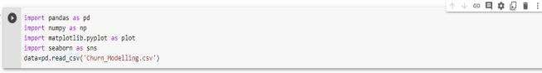

1. perform below visualization

 Univarient

 Bi-varient

 Multi-varient

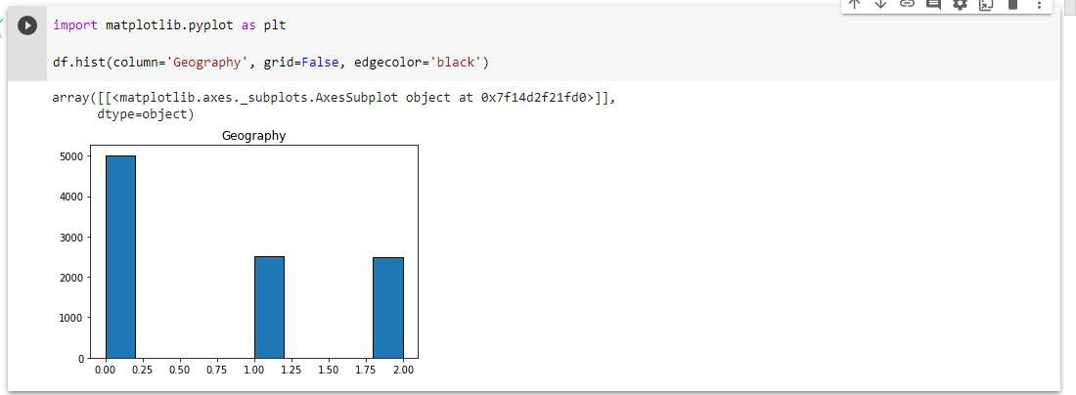

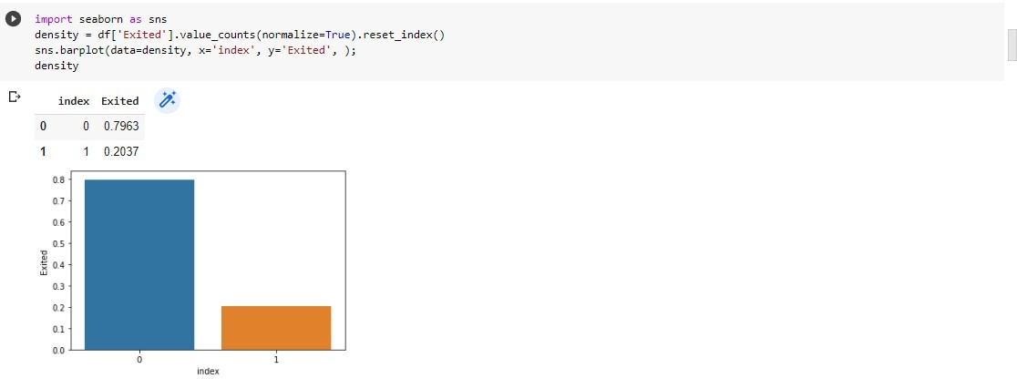

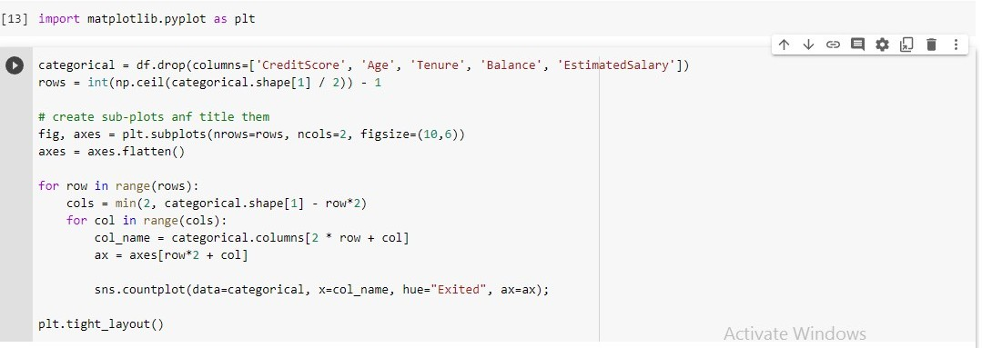

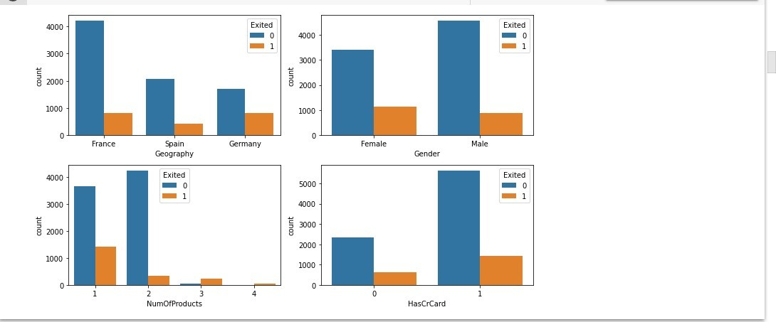

1. Perform the descriptive statistics on the datase

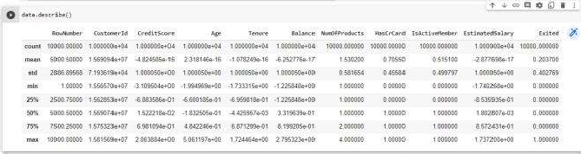

1. . Handle the missing values

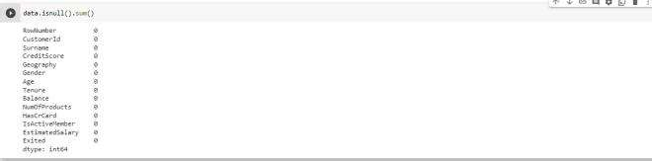

1. Find the outliers and replace the outliers

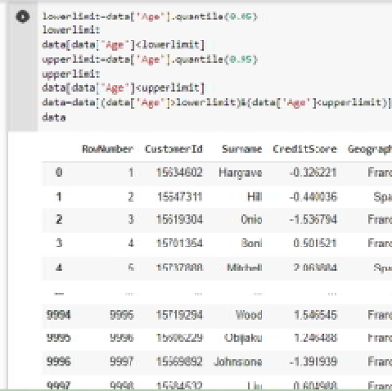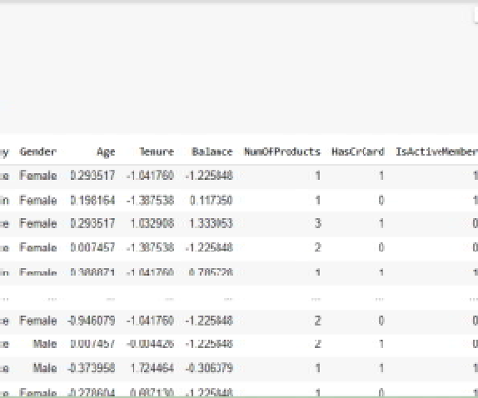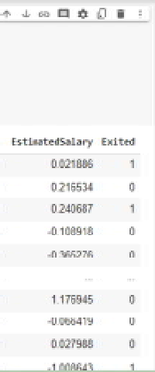

1. 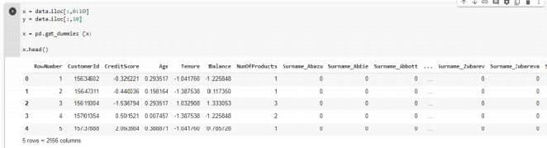Check the categorical columns and perform encoding
2. Split the dataset into ipdendent and dependent variables.

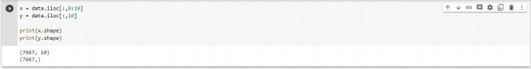

1. Scale the independent variable

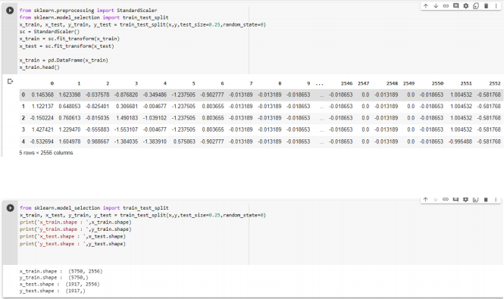

10. Split the data into training and testing